Please indicate the extent to which each statement accurately describes you by writing the appropriate number from the scale below in the space provided.

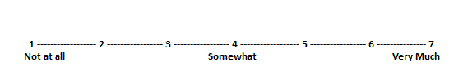

____ Members of my peer group respect and admire me.

____ Members of my peer group do NOT want to be like me.

____ I enjoy having control over others.

____ Others always expect me to be successful.

____ I often try to get my own way regardless of what others may want.

____ Others do NOT value my opinion.

____ I am willing to use aggressive tactics to get my way.

____ I am held in high esteem by those I know.

____ I try to control others rather than permit them to control me.

____ I do NOT have a forceful or dominant personality.

____ Others know it is better to let me have my way.

____ I do NOT enjoy having authority over other people.

____ My unique talents and abilities are recognized by others.

____ I am considered an expert on some matters by others.

____ Others seek my advice on a variety of matters.

____ Some people are afraid of me.

____ Others do NOT enjoy hanging out with me.